

UNIVERSIDAD FRANCISCO DE VITORIA

**ESCUELA POLITÉCNICA SUPERIOR**

**GRADO EN INGENIERÍA INFORMÁTICA**

APLICACIÓN DE LA ROBÓTICA Y EL IOT

**HOME SECURITY SYSTEM**

Diego Viñals Lage

Daniel Sanchez Casado

Index

1. Introduction 1

2. State of the art 3

2.1. SimpliSafe 3

2.2. Ring 4

3. Objectives 7

3.1. General Objective 7

3.2. Specific Objectives 7

4. Development 9

4.1. Materials and Components 9

4.2. Wiring and Connections 10

4.3. Programming the Arduino 11

5. Results 13

5.1. Potential Improvements 14

6. Conclusions 17

7. References 19

Images Index

Figure 1: Connections and Connectivity 10

Figure 2: Alarm Activated 14

# Introduction

This project explores the intersection of robotics and the Internet of Things (IoT) by developing a home alarm system powered by Arduino. In an increasingly interconnected world, home security has become a top priority for individuals and families alike. Leveraging the advanced capabilities of microcontrollers like Arduino, this project aims to design an efficient, cost-effective, and user-friendly alarm system that offers a comprehensive security solution for homes.

The system utilizes Arduino's connectivity technology to link various sensors throughout the house, such as motion detectors, door/window sensors, and cameras, creating an intelligent security network. Upon detecting a threat, the system will not only activate an audible alarm to deter intruders and alert residents but also send real-time notifications to users' mobile devices, allowing them to take immediate action, regardless of their location.

Moreover, this project showcases the practical application of emerging technologies in everyday life and highlights how the integration of robotics and IoT can enhance security and peace of mind in the domestic environment. With a focus on accessibility and effectiveness, this home alarm system promises to be a valuable addition to any household, adapting to modern security needs with cutting-edge technology.

Expanding further, the project includes a detailed analysis of potential security vulnerabilities in a typical home setting and how our Arduino-based system can address these through advanced detection algorithms and immediate notification mechanisms. Additionally, it explores the potential for future integration with smart home ecosystems, allowing for an even more seamless and automated approach to home security. By providing a blueprint for a scalable, adaptable, and intelligent security system, this initiative represents a significant step forward in the use of technology to protect our homes and loved ones.

# State of the art

This segment delves into the current landscape of home security solutions, highlighting key innovations in sensor technology, IoT integration, and smart home connectivity. We examine how the fusion of robotics and IoT has led to smarter, more responsive security systems that offer unprecedented levels of protection and convenience to homeowners.

Our exploration begins with an analysis of the current market leaders in home security, identifying the core technologies that set their systems apart, such as AI-driven cameras, advanced motion detection algorithms, and seamless smart home integration. By understanding these benchmarks, we can better position our NodeMCU-based alarm system within the broader context of what is technically feasible and what consumers expect from a modern home security solution.

Furthermore, this section addresses the challenges and limitations inherent in existing systems, such as issues of privacy, the potential for false alarms, and the complexities of installation and maintenance. By critically assessing these areas, we can identify opportunities for innovation and improvement in our project.

Our review of the state of the art not only establishes a foundation for the technical specifications and design choices of our system but also sets the stage for future research and development. It underscores our commitment to pushing the boundaries of what is possible in home security, aiming to deliver a solution that is not only at the forefront of current technology but also anticipates the needs and challenges of tomorrow's home security landscape.

## SimpliSafe

SimpliSafe is highly regarded for its straightforward, no-pressure sales approach, optional subscription services, and ease of use, making it a top choice for a home security system today. Despite its simplicity, it may not be the best fit for those looking for extensive smart home integration or those who dislike the mandatory 30-day trial of its professional monitoring service.

The value of a home security system is undeniable, potentially saving homeowners from substantial losses due to burglary, which averages over $2,600 per incident. With the annual cost of a security system around $400 after equipment, the investment in security is deemed worthwhile, especially considering possible discounts on homeowners insurance​​.

Modern systems offer a variety of components like smart smoke and carbon monoxide detectors, water leak detectors, and keychain fobs for remote arm/disarm capabilities, enhancing the traditional door and window sensors. These additions not only provide peace of mind but also introduce functionality beyond basic security measures​​.

Security systems function by detecting unauthorized entry and alerting homeowners through loud sirens and, if subscribed, notifying professional monitoring services that can dispatch emergency services. The presence of a security system itself acts as a deterrent to potential burglars, often preventing attempts before they happen. Some systems also allow for self-monitoring, giving homeowners direct control over the security alerts and responses through mobile apps​​.

## Ring

Ring's home security system is celebrated for its straightforward setup and a broad selection of cameras at competitive prices. It supports small homes and those with tight security budgets. The system is easy to install and manage through the app, although some users have encountered difficulties with the keypad for arming and disarming.

Ring's expansive camera selection makes it an excellent choice for building a system centered around video surveillance. However, some have raised privacy concerns regarding Ring's Neighbors app and police partnerships, advising users to thoroughly understand Ring's privacy policies.

Ring offers an easily installable home security system suitable for various budgets and needs, with options for DIY or professional installation. It's particularly noted for its comprehensive camera lineup and affordability.

While its app enhances user experience and system control, privacy concerns around its Neighbors app and police partnerships have been raised. Users must review Ring's privacy practices to make informed decisions about their home security and community interaction. [1]

Ring's home security system stands out for its comprehensive range of products, including video doorbells, indoor/outdoor cameras, and smart lighting, all designed to integrate seamlessly with the Ring app for easy monitoring and control.

The system's flexibility, from DIY installation to professional monitoring options, caters to diverse security needs and budgets. However, potential users need to weigh the benefits against privacy concerns related to the Neighbors app and partnerships with law enforcement.

In comparing Ring and SimpliSafe, both offer robust home security solutions with distinct strengths. Ring, owned by Amazon, provides an extensive range of smart home-compatible devices and cameras, emphasizing flexibility and integration. SimpliSafe, renowned for its simplicity and effectiveness, caters to those seeking straightforward, reliable home security without the need for complex setups. While Ring offers broader smart home integration and customizable options, SimpliSafe appeals for its user-friendly design and efficient monitoring services. Users must weigh Ring's extensive features against SimpliSafe's simplicity and privacy considerations when choosing the optimal home security solution.

When evaluating Ring and SimpliSafe as state-of-the-art home security solutions, it's clear each system caters to distinct preferences. Ring offers a comprehensive suite of smart home devices for those valuing integration and customization. SimpliSafe, on the other hand, is ideal for users seeking simplicity and effectiveness without the complexity of smart home integration.

The choice between them hinges on prioritizing either smart home capabilities and customization (Ring) or straightforward security with minimal setup (SimpliSafe), alongside considering privacy aspects related to external app integrations.

# Objectives

This project primarily aims to design and implement a home alarm system based on Arduino, leveraging Internet of Things (IoT) technology to provide an advanced, accessible, and efficient security solution. The objectives are crafted to ensure that the system not only enhances home security but also integrates seamlessly with modern smart home ecosystems, providing users with a comprehensive and user-friendly experience.

## General Objective

The cornerstone of our project is the development of a comprehensive security system that fundamentally transforms the way homeowners approach their home security. By integrating a sophisticated array of sensors and cameras, this system is engineered to detect and instantly notify homeowners of any suspicious or unauthorized activities occurring within their premises.

Utilizing advanced technologies such as motion detectors, door/window sensors, and exploring the potential for sound or vibration sensors, we aim to construct a multi-layered security solution. This robust approach ensures that every corner of the home is monitored, providing peace of mind and a new level of security to individuals and families alike.

## Specific Objectives

The specific objectives of our project are meticulously designed to anchor the development of a cutting-edge, Arduino-based home alarm system. By leveraging the potent capabilities of IoT technology, these objectives outline a roadmap for creating a security solution that is not only technologically advanced but also user-centric and environmentally conscious. Each objective targets a critical aspect of the system's functionality, from enhancing real-time security monitoring to ensuring the system's adaptability and sustainability.

Together, they form a comprehensive blueprint aimed at revolutionizing home security, making it more accessible, efficient, and responsive to the evolving needs of homeowners worldwide. This strategic approach sets the stage for a project that promises to redefine the standards of home safety and security in the digital age.

* **Develop a comprehensive security system**: Create a system that uses sensors and cameras to detect and notify in real time any suspicious or unauthorized activity within a home.
* **Implement wireless communication for remote monitoring**: Utilize Bluetooth or RF modules with Arduino to enable users to monitor their home through a dedicated mobile application or interface, ensuring connectivity even in areas with limited WIFI coverage.

# Development

## Materials and Components

To successfully build the Arduino-based home alarm system, it is essential to gather all the necessary materials and components. Below is a comprehensive list of the required items:

* **Arduino Board**: The central microcontroller that will manage and control all the components of the alarm system. Common choices include Arduino Uno, Arduino Nano, or Arduino Mega.
* **Motion Sensor (PIR):** Passive Infrared (PIR) sensors detect motion by measuring infrared radiation changes in their environment. They are crucial for detecting intruders.
* **Camera (Optional):** A camera module can be integrated to capture images or video when motion is detected, providing visual evidence of any intrusion.
* **Buzzer (for sound alarm):** The buzzer emits a loud sound to alert you of any detected motion. It serves as the primary audible alarm.
* **LEDs (Visual Indicators):** LEDs act as visual indicators to show the status of the system, such as power on, motion detected, or alarm activated.
* **LCD Module**: The Liquid Crystal Display (LCD) module displays important information, such as system status, alerts, or messages.
* **Wires and Breadboard:** Wires are used to connect the various components, while the breadboard allows for easy and temporary prototyping of the circuit.
* **Power Supply**: A suitable power supply is necessary to provide the required voltage and current to the Arduino and connected components. This could be a battery pack or a regulated power adapter.
* **Resistors**: These are often needed to ensure the proper functioning of sensors, LEDs, and other electronic components.
* **Push Buttons**: Used for user input, such as arming or disarming the alarm system.

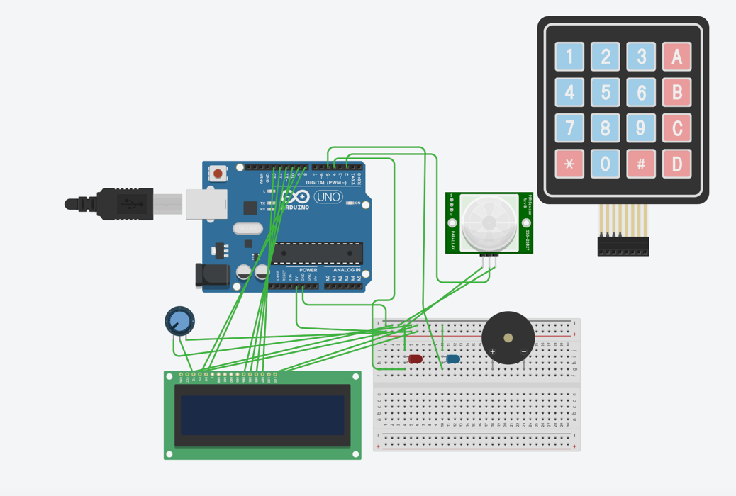

Figure 1: Connections and Connectivity

In the image above, a basic schematic diagram of the circuit is shown, illustrating how the components are interconnected to form the Arduino-based home alarm system.

## Wiring and Connections

### LCD

The LCD is connected to the Arduino using the following pins:

The RS pin is connected to pin 8, the EN pin is connected to pin 9, the D4 pin is connected to pin 10, the D5 pin is connected to pin 11, the D6 pin is connected to pin 12, and the D7 pin is connected to pin 13.

### Motion Sensor (PIR)

The motion sensor (PIR) is connected as follows:

The VCC pin is connected to the 5V pin of the Arduino, the GND pin is connected to the GND pin of the Arduino, and the OUT pin is connected to digital pin 2 of the Arduino, which is defined as Sensor in the code.

### Green and Red LED Connection

For the green LED (LEDG), the anode (positive leg) is connected to digital pin 5 of the Arduino, and the cathode (negative leg) is connected to GND through a 220-ohm resistor. For the red LED (LEDR), the anode (positive leg) is connected to digital pin 4 of the Arduino, and the cathode (negative leg) is connected to GND through a 220-ohm resistor.

### Buzzer Connection

The buzzer is connected as follows:

The positive pin is connected to digital pin 3 of the Arduino, and the negative pin is connected to GND.

### Keypad Connection

The keypad has 4 rows and 4 columns and is connected as follows:

The first-row pin is connected to pin 22 of the Arduino, the second-row pin is connected to pin 23 of the Arduino, the third-row pin is connected to pin 24 of the Arduino, and the fourth-row pin is connected to pin 25 of the Arduino. The first column pin is connected to pin 26 of the Arduino, the second column pin is connected to pin 27 of the Arduino, the third column pin is connected to pin 28 of the Arduino, and the fourth column pin is connected to pin 29 of the Arduino.

## Programming the Arduino

### Setting Up the Development Environment

The initial step involves setting up the development environment by installing the Arduino IDE (Integrated Development Environment) on a computer. The Arduino IDE, available on the official Arduino website, supports various operating systems such as Windows, macOS, and Linux.

### Installing Required Libraries

The project utilizes several libraries to handle the LCD, keypad, and software serial communication. The necessary libraries are:

* Keypad.h: Manages the keypad inputs.
* LiquidCrystal.h: Controls the LCD.
* SoftwareSerial.h: Allows serial communication on other digital pins of the Arduino.

These libraries can be installed through the Library Manager in the Arduino IDE by navigating to "Sketch > Include Library > Manage Libraries" and searching for each library by name.

### Writing the Code

The code for the Arduino-based alarm system includes several key functions. These functions are crucial for initializing components, reading inputs, monitoring sensors, activating alarms, and sending notifications.

1. **Include Libraries and Define Pins**: The necessary libraries are included at the beginning of the code, and the pins for the LCD, sensors, LEDs, buzzer, and communication module are defined.
2. **Setup Function**: The setup function initializes the components. This includes setting the pin modes and starting serial communication. During this phase, the LCD is initialized, and a welcome message is displayed. Additionally, the initial state of the system is communicated via a notification sent through the communication module.
3. **Loop Function**: The loop function continuously checks for keypad inputs, monitors the states of the sensors, and controls the alarm system based on the inputs received.
   1. Keypad Input Handling: The system reads inputs from the keypad to activate or deactivate the alarm. If the correct activation code is entered, a countdown timer starts, allowing the user to exit the premises before the alarm is fully armed. If the correct deactivation code is entered, the alarm is deactivated.
   2. Sensor Monitoring: The system monitors the motion sensor and door/window sensors. If any sensor detects an intrusion while the alarm is active, the system triggers the alarm by sounding the buzzer and flashing the LEDs. A notification is also sent to alert the user of the detected movement.
   3. Alarm Activation and Deactivation: The system activates the alarm (buzzer and LEDs) when an intrusion is detected. The alarm remains active until the correct deactivation code is entered via the keypad.

### Uploading the Code to the Arduino

To upload the code to the Arduino board, the board is connected to the computer using a USB cable. The Arduino IDE is then used to load the provided code. The appropriate Arduino board model and COM port are selected in the Arduino IDE. The upload button is clicked to compile and upload the code to the Arduino board. Once successfully uploaded, the Arduino-based alarm system should operate according to the programmed logic

# Results

The Arduino-based home alarm system was successfully designed, implemented, and tested, yielding the following results:

* Sensor Integration and Responsiveness: The system effectively integrated various sensors, including motion detectors and door/window sensors. These sensors consistently detected movements and openings, triggering the alarm as intended. The responsiveness of the sensors was verified through multiple tests, demonstrating reliable detection of unauthorized activities within the home environment.
* Alarm Activation and Deactivation: The alarm system accurately responded to the activation and deactivation codes entered via the keypad. The correct activation code initiated a countdown timer, allowing the user to exit before the system was fully armed. The deactivation code successfully disarmed the system, stopping the alarm and returning the system to a standby state.
* Visual and Audible Alerts: Upon detecting an intrusion, the system activated the buzzer and LED indicators, providing immediate audible and visual alerts. The alarm was loud and clear, ensuring that any unauthorized activity was promptly noticed. The LEDs functioned as expected, with the green LED indicating an active system and the red LED flashing during an alarm event.
* User Interface and Experience: The LCD provided clear and concise messages, guiding the user through the process of activating and deactivating the alarm system. The input code was displayed on the LCD, ensuring that the user could verify their input. The system's interface was user-friendly, with straightforward keypad operations and easily understandable messages displayed on the LCD.
* Real-time Notifications: Unfortunately, the implementation of real-time notifications via the communication module could not be achieved. Despite multiple attempts to establish a reliable communication link between the Arduino and a mobile device, the system faced persistent issues with message transmission and reception. As a result, users were not able to receive real-time alerts about system activation, deactivation, and detected movements.

Below is a photo of the alarm system in an active state, with the blue LED illuminated.

Figure 2: Alarm Activated

The alarm system takes 30 seconds to activate, allowing enough time to exit the house. Once activated, if it detects any movement, the red LED lights up and the alarm sounds.

## Potential Improvements

* Enhanced Security Features: Future improvements could include the addition of more advanced sensors, such as glass break detectors or vibration sensors, to enhance the system's detection capabilities. Implementing encrypted communication between the Arduino and the mobile device could further secure the system against potential hacking attempts.
* Smart Home Integration: Integrating the alarm system with existing smart home ecosystems, such as Google Home or Amazon Alexa, could provide users with more convenient control options and enhanced automation capabilities.
* User Feedback and Customization: Incorporating user feedback mechanisms could help in refining the system based on real-world usage and preferences. Allowing users to customize alert tones and notification settings could improve the overall user experience.

The Arduino-based home alarm system successfully met most of its objectives of providing an advanced, accessible, and efficient security solution. The system demonstrated reliable performance in detecting intrusions, activating alarms, and providing user-friendly interface and controls. However, the implementation of real-time notifications was not successfully achieved, limiting the system's capability to alert users remotely. With potential enhancements and integrations, the system can be further developed to provide even more comprehensive home security, adapting to the evolving needs of homeowners in the digital age.

# Conclusions

The conclusions drawn from the execution of this project are as follows:

* The Arduino-based home alarm system has been successfully designed and implemented, achieving most of its intended objectives.
* The system demonstrated reliable integration of various sensors, effective alarm activation, and user-friendly interaction through the keypad and LCD display.
* The motion detectors and door/window sensors consistently detected unauthorized activities, triggering the alarm system as intended.
* The system provided clear visual and audible alerts, ensuring immediate notification of any intrusions.
* The objective of implementing real-time notifications via the communication module was not fully achieved.
* The NodeMCU was included in the setup to connect to the internet and send notifications, but the process faced significant challenges and was not completed within the project timeframe.
* Persistent issues with establishing a reliable communication link prevented the system from sending immediate alerts to users' mobile devices.
* Efforts to integrate the NodeMCU for internet connectivity indicate potential for future enhancements.
* There was an attempt to include a camera in the system to take a photo when the alarm sounded, but this was not accomplished because it required setting up a server and storing the photos on it, which was too complex for this project.
* The unresolved objective of real-time notifications highlights an area for future improvement.
* With additional time and resources, the system could be further developed to include reliable remote alert capabilities and camera functionality, enhancing its overall effectiveness and user experience.

# References

|  |  |
| --- | --- |
| [1] | A. Bradford, «SafeWise,» 17 November 2017. [En línea]. Available: https://www.safewise.com/blog/ring-security-system-review/. [Último acceso: 27 February 2024]. |